Here is an example for fluentd logging configuration.

1. Cloud functions part:

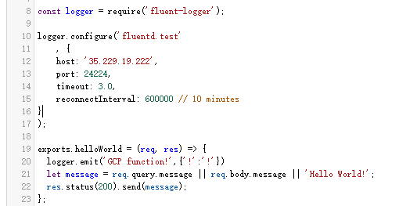

Make the call to the fluentd server when we use Cloud functions

This part is a piece of code inside the cloud function. The procedure can be:

* Install the fluent-logger dependency for the node backend.
* Fill in the logger.configure part: the host and port should be the fluentd server external IP and the corresponding port.
* Define logger.emit for each function(i.e. The expected log info we want to show. Eg: time, function name)

1. Fluentd server part:

First, we need to install the fluentd environment for the fluentd server(i.e. Our VM instance). See <https://docs.fluentd.org/v1.0/categories/installation>

Second, set up td-agent.conf file to define the input and output. Currently I was using:

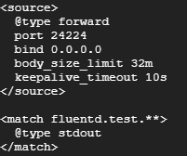

Then the td-agent.conf can be found at: /etc/td-agent/td-agent.conf, the output location is at: /var/log/td-agent/td-agent.log

You may want to try to call: <https://us-central1-fluent-logging.cloudfunctions.net/Testing> with your internet browser, see “Hello word” from that page and see this in the /var/log/td-agent/td-agent.log file:



It automatically generates the log info based on the rule define in the GCP function(i.e.{“!”:”!”}).

C. In terms of visualizing the results, my suggestion is **Fluentd + Prometheus.** Some research is still needed for this part. See <https://docs.fluentd.org/v0.12/articles/monitoring-prometheus>

Finally the visualization would be: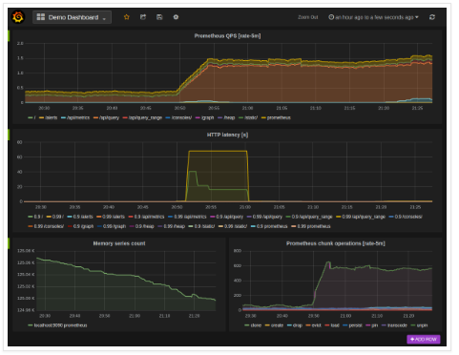

Some helpful tips can be found in readme.txt.